- Introduction
- Project Title: Store Manager: Keep Track of Inventory
- Team ID: NM2025TMID47635
- Team Leader: SAMUVASAGAM S & samuvasagams@gmail.com
- Team Members:
– PRAVEEN RAJ P & pr956845@gmail.com
– PARTHA SARATHI G & sarathi9342881519@gmail.com
– PRASANNA G & pg5624894@gmail.com

- Project Overview
- Purpose: To provide an efficient inventory management system that ensures real-time stock updates, smooth sales checkout, and timely alerts for low inventory.
- Features:
– Real-time Stock Updates
– Cart & Checkout Management
– Low Stock Alerts
– Product Management

- Architecture
- Frontend: React.js with Bootstrap and Material UI
- Backend: Node.js and Express.js managing server logic and API endpoints
- Database: MongoDB stores user data, project information, applications, and chat messages

- Setup Instructions
- Prerequisites:
– Node.js
– MongoDB
– Git
– React.js
– Express.js
– Mongoose
– Visual Studio Code

- Folder Structure
inventory-management-frontend/
├ node_modules/
├ public/
├ src/
├ components/
├ Cart/
├ Inventory/
├ Product/
├ Sales/
├ context/
├ pages/
├ hooks/

- Running the Application
- Frontend:
cd client
npm start
- Backend:
cd server npm
start
- Access: Visit htp://localhost:3000

- API Documentation
- User:
– /api/user/register
– /api/user/login
- Projects:
– /api/projects/create
– /api/projects/:id
- Applications:
– /api/apply
- Chats:
– /api/chat/send
– /api/chat/:userId

- Authentication
- JWT-based authentication for secure login
- Middleware protects private routes

- User Interface
- Landing Page
- Freelancer Dashboard
- Admin Panel
- Project Details Page

- Testing
- Manual testing during milestones
- Tools: Postman, Chrome Dev Tools

- Screenshots or Demo
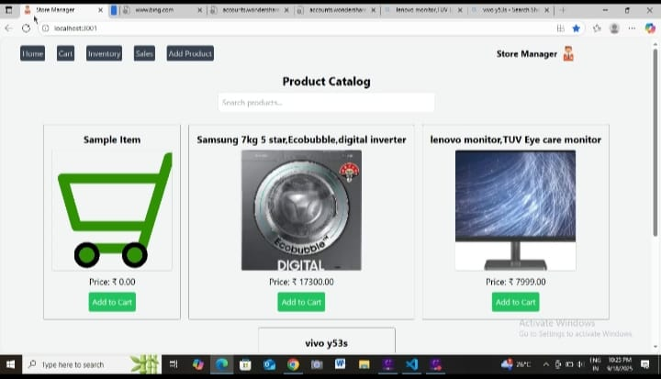
Drive link of Demo Video:
https://github.com/samuvasagams-afk/store-manager/commit/63af05b07280f22ceb692572204f91c8cafc78a6
- Known Issues: No Issues.

- Future Enhancements: In feature we can upgrade the page for our need.

